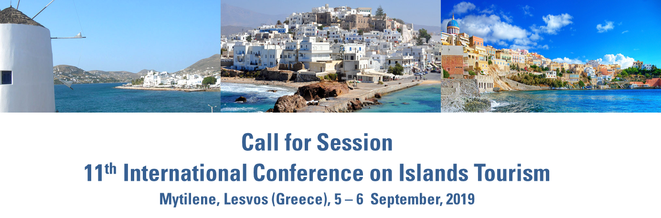

The ICIT International Conference on Islands Tourism promotes the scientific and technical exchange between international academics and experts on insular contexts in order to address efficient strategies for insular development by promoting a wide cooperation. The meeting includes a variety of topics relevant for the Islands Tourism and suited for many disciplines, including : Tourism , Economy, Policies, Environmental issues, business development, and more.
Be a part of the INTERNATIONAL CONFERENCE ON ISLANDS TOURISM by submitting a proposal for the 11th edition. The call for sessions will remain open until the 21st of July.
There are three different session formats that you can choose:
- Standard Session – this is your typical session that is composed of 20 minute papers presented by the participants.
- Roundtable – this is a session format where the session organizer(s) present a position paper in advance of the conference and invite participants to discuss the topic in an open format.
- Other –OTIE encourages new session formats to create a dynamic environment for sharing projects and ideas. Please indicate a description of what the session format would look like.
Proposals should include a session title, description of the topic of the session, and a list of potential speakers, indicating the subject of their presentation.
Please note that, each submitter may submit up to 3 proposals.
Please follow these guidelines for proposal :
- Proposal could be addressed to the following themes:
- Business cooperation in fragile contexts
- Brand effects at the destination
- Developing strategic tourism planning for islands
- Development for Religious Based Tourism in Islands

- Economic/Social/Environmental/Cultural Impacts of Tourism
- European Union Policies for Tourism
- Effects of climate changes on seasonality and insular tourism
- Faith and spiritual destinations
- Managing events for islands development
- Local development and transport system
- Nautical and cruise tourism
- Relational tourism challenges and opportunities
- Tourism accessibility for development
- Theoretical Perspectives on Sustainable Tourism
- Tourism Sustainable Development for islands
- Tourism industry
- Innovation in tourism
- Big data and statistical analysis in tourism studies
- Culture, language and geography perspectives
- Others

- Provide a 10 words session title.
- Describe your session proposal in 500 words or less. Please, provide also 4/5 keywords
- Specify the format of the session when you submit (Standard, Roundtable, Other)
- Identify and provide contact information for:
- The session organizer (maximum 3)
- Suggested speakers (minimum 4/maximum 6)
- Suggested One moderator

The form to submit the session proposal is available on the OTIE website page. Please, fill it and send it to research@otie.org

Organizer Responsibilities:
Session organizers should inform the speakers and moderators of the submission, confirm the availability of moderator and all speakers to participate in the session, and inform that they will have to register for the conference to participate in the session. Organizers also support OTIE during the planning of the ICIT by communicating with the moderator and speakers and to gather information about the speakers and share information from OTIE about the ICIT.

